

Vacuum Oven

VO-16092

Operation Manual
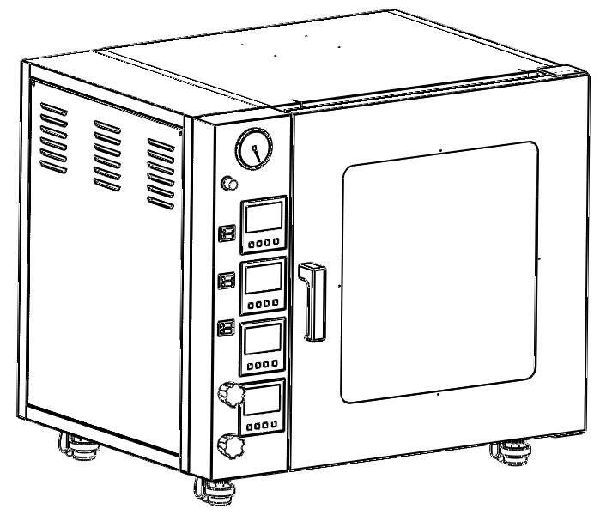

PHAETON SCIENTIFIC INC
11331 183rd Street #1012, Cerritos, CA 90703

● The operation manual please sent to the operator hands!

● Please read and understand the product specification before operate instrument.
For adverse consequences caused by wrong operation, our company is not responsible for.

● The contents of the operation manual may make changes and improvement in the future, there will be not the notice, please understanding.

● If found abnormal phenomenon in the process of use, please do not hesitate to contact our company.

● Please keep the operation manual, at the same time, please be sure to fill in and send the warranty card to our after-sales service center.

Product model: | VO-16092
Serial number: | DZF090DB0238
Manufacturing date: | 2019-03

Contents
- Safety instruction ………………………………………………………………………………………… 4
- Application ………………………………………………………………………………………………….. 4
- Structure …………………………………………………………………………………………………….. 5
- Working condition ………………………………………………………………………………………. 6
- Technical parameters ………………………………………………………………………………….. 6
- Use method ……………………………………………………………………………………………… 7-11
- Maintenance ……………………………………………………………………………………………… 12
- Problem solution ……………………………………………………………………………………..… 12

- Safety instruction
Dangerous！
1. Must be connect with the ground.
2. When the instrument is smoking vacuum or heating, do not allow to touch the door and window, must stand at more than one-meter distance from door.
3. Shall not dry inflammable, explosive, volatile and corrosive substances.
4. When need not to smoke air continuously, should shut off the vacuum valve firstly, then close the vacuum motor power switch, in order to prevent the vacuum pump oil flow backward to tank.
5. If the oven is broken, must be repaired by professional maintenance person.
6. If need to repair electrical parts, must be repaired by electrical engineer.

Warning! (May cause a serious property damage or loss of life)
1. Must fully read and understand operation manual, before operate the instrument.
2. When replace the fuse and electric parts, must pull the plug.
3. When the instrument is not used for long time, must pull the plug.

- Application
The vacuum oven is widely used in biochemistry, chemical and pharmaceutical, health care, agricultural research, environment protection and other areas of research and application for powder drying, baking and all kinds of glass containers’ disinfection and sterilization. Especially for those drying heat-sensitive, labile, oxidizing material and decompounded to carry on fast and effective drying process.

3. Structure
VO-16092 is with four shelves heating. The oven body is made from high quality carbon steel stamping, the surface is electrostatic spraying and the chamber is stainless steel. Thermal insulation layer is made of high-quality silicate cotton, there is a high temperature resistant silicon rubber sealing ring between the chamber and the window, which ensure the sealed performance between the chamber and the door, increase substantially the vacuum degree in the oven.
Temperature control system use the PID temperature controller with touch button, do not need to adjust temperature control parameters, control precision and no overshoot. Temperature control system has the function of timing and over temperature protection, which improve the equipment safety.
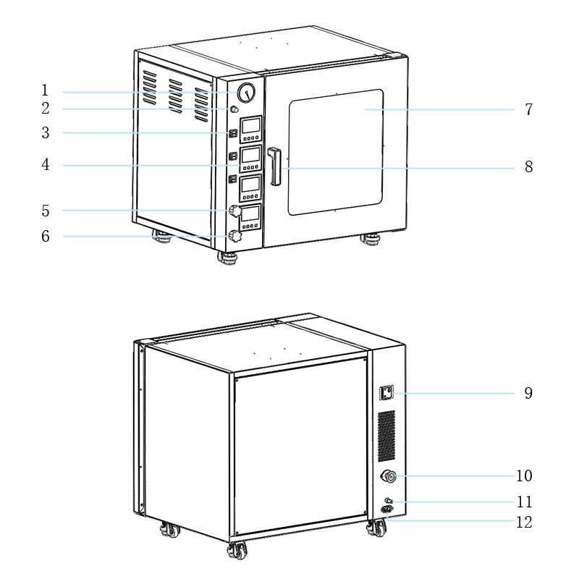

1. Vacuum gauge | 2. Air outlet hole | 3. Power and LED light switch
4. PID temperature controller | 5. Vacuum valve | 6. Inert gas inlet valve
7. Observation window | 8. Door handle | 9. Leakage protection switch
10. KF25 vacuum pump hole | 11. Inert gas inlet hole | 12. Power socket

4. Working condition
(1). Environment temperature: +5～40ºC
(2). Relative humidity: ≤85%RH
(3). Atmospheric pressure: 86～106Kpa
(4). Around without intense shaking, clearance is more than 50 cm.
(5). There are not direct sunlight and heat radiation.
(6). There is not a strong airflow blowing straight body.
(7). There is not high concentration of dust and corrosive materials.

5. Technical parameters
Model | VO-16092
Power Requirement | 110V/60HZ
Power Consumption | 1400W
Temperature Range | RT+10～150 ºC/RT+50～300ºF
Temperature Stability | ±1 ºC/±1 ºF
Display Resolution | 0.1 ºC/0.1 ºF
Vacuum Range | ≤133Pa
Timing range | 1～9999min
Chamber Size | 450X450X450 (WXDXH mm)  1.48X1.48X1.48 (WXDXH ft)
Oven Size | 765X660X695 (WXDXH mm)  2.51X2.17X2.28 (WXDXH ft)
Volume | 90L/3.2CF
Standard Shelves | 4pcs  (Fixed)
6. Use method
(1). Installation
The vacuum oven should be placed in the room with good ventilation, without intense shaking and flammable items.

(2). Basic operation
①. When start to use, close the door, air outlet hole and inlet hole switch, then open the pump hole switch.
②. If you only need vacuum function, use the vacuum tube to connect the vacuum pump with KF25 pump hole which is in the back of oven, turn on the vacuum pump power to start pumping. When the vacuum gauges indicating needle reach to -0.1 MPa or your required vacuum degree, turn off the pump hole switch firstly, and then turn off the vacuum pump. At this time, there is vacuum state in the chamber.
③. If you need vacuum and heating function, turn on the vacuum oven power after the oven is in the vacuum state. Then set required temperature, the temperature controller display shows two rows, the first row is the actual measured temperature and the second is the setting temperature. When the measured temperature reaches to the setting temperature, the heating light flash, enter constant temperature state, the oven is working properly.
④. After using, turn off the power and open air outlet hole. When the vacuum gauges indicating needle reach to 0 MPa, then can open the door.

(3). Panel indication
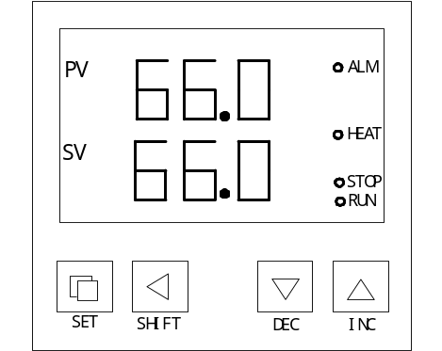
①. RUN/AT: This symbol is bright when the controller is running, when the runtime is over, this
indicator is not bright.
When the controller enters the auto-tuning of PID, this indicator is flashing.

②. STOP: This symbol is bright to show you timing program is over.

③. HEAT: This symbol is bright to show you the heater is working.

④. ALM: This symbol is bright to show you over-temperature alarming.
(4). Using method of temperature controller
①.When the controller is switched on, display windows show ‘In index (P, C, K, S)’ and the value of temperature range for 3 seconds, then it starts running.

②.Temperature and time settings:
Press the “Set” button, the controller runs into the temperature setting state. Re-press the ‘Set’ button, the controller runs into the time setting state. In setting state, you can use the ‘◄’, ‘▼’ and ‘▲’ buttons to get the required setting values. Press the ‘set’ button again, it returns from the setting state and the setting values are saved automatically.
If the time is set as ‘0’, the controller will run continuously, the display window of ‘SV’ will display the setting temperature. If the time set value is not ‘0’, timers start timing when the measuring temperature reaches the setting temperature, the display window of ‘SV’ will display the time. (If En= ‘0’, when the timing is over, the ‘SV’ window will display ‘End’, the buzzer will sound for 30s, off all outputs; If En=1, when the timing is over, the ‘SV’ window doesn’t show ‘End’, the buzzer sounds for 30 seconds, temperature continue to constant temperature. After the end of operation, long press ‘shift / run’ button for 3 seconds can restart the timer operation.

③.When temperature alarm, the buzzer will sound and ‘ALM’ will bright. If a change in temperature setting and over-temperature alarm, ‘ALM’ lights up, but no sound.

④.When the buzzer sounds, it can be muted by pressing any button.

⑤. ‘◄’ SHIFT button: In the setting state, can touch the button to move cursor.

⑥. ‘▼’ REC button: In the setting state, can touch the button to reduce the setting value.
If touch and hold the button, the set value will reduce continuously.

⑦. ‘▲’ INC button: In the setting status, can press the button to increase the set value.
If touch and hold the button, the set value will increase continuously.

⑧.In setting state, the controller will return to run status if any key without touch in one minute.

⑨.If the display window shows ‘----', it indicates the fault of temperature.

(5). Auto-Tuning
When the temperature control effect is not ideal for system tuning. Self-tuning process temperature can have bigger overshoot, the users in a system setting before please consider this factor.

In not running state, the controller will enter the auto-tuning of PID by touch the ‘◄’ button for 6S, ‘RUN/AT’ indicator flashes, it will be not bright when the auto-tuning of PID is completed. In the state, when the auto-tuning of PID after the end of a group of PID parameter, parameter automatic saves and return to the normal mode of operation. When running the auto-tuning of PID, it can be stopped by touch the ‘◄’ button for 6S again.

In the auto-tuning of PID state, if temperature alarm, no sound buzzer and ‘ALM’ don’t light, but heating alarm relay automatic disconnect and ‘set’ keys to effective. In the system self-tuning process regardless of whether there is a constant temperature time setting, controller display window lower always displays the temperature setting value.

(6). Internal parameters settings
Touch the ‘Set’ button for 3 seconds, controller will display the password prompt ‘Lc’. Adjust the password to the required value, then touch the ‘Set’ button again, it will run into the internal parameter setting state. If touch the ‘Set’ button for another 3 seconds, it will return to the running state.

Parameter list-1:
Parameter indicator | Name | Instruction of the Parameter’s function | Factory set value  (Setting range)
Lc- | Password | when Lc=3, then we can see and modify parameters | 3
AL- | Alarming setting | When temperature is over “SP+AL”, the Alarm indicator turns on. The buzzer sounds and the heater output turns off. | 5 ºC (0～100 ºC)
T- | Control cycle | The heat control cycle of temperature | 20S (1～60S)
P- | Proportional band | Adjustment of proportional parameter. | 30 (1.0～rH)
I- | Integration time | Adjustment of integration parameter. | 400 (1～1000)
d- | Differential time | Adjustment of differential parameter. | 200 (0～1000)
Pb- | Zero point adjust | When the zero error comparatively larger, to update this value should be needed.  Pb=measure value –actual value | 0 ºC (-50～50 ºC)
PK- | Full point adjusts | When the full point error also comparatively larger, to update this value should be needed.  PK=1000×（measure value –actual value）/ actual value. | 0 (-999～999)
Et- | Timing function | When ET = 0, no timing function; 1 electric start timing, 2 to the value set start timing. | 0 (0～2)
Note 1: If the selection of relay output, heating control cycle should be selected in 20 seconds, the other models for 5 seconds.
Parameter list-2:
Parameter indicator | Name | Instruction of the Parameter’s function | Factory set value  (Setting range)
Lc- | Password | when Lc=9, then we can see and modify parameters | 9
Co- | Turn off the heat output deviation | when“PV≥SP+Co”，Turn off the heating output。 | 5.0 ºC (0.0～50.0 ºC)
Hn- | Constant temperature time mode | 0：minutes；1：hours | 0 (0～1)
En- | End of operation temperature | En = 0 end of run off output;  En = 1 end run to constant temperature; | 0 (0～1)
Lt- | Maximum power output | The heating output maximum power percentage | 100 (0～100)
rH- | Range of temp setting | The value of temperature setting. | 150 ºC (0～350)

Parameter list-3:
Parameter indicator | Name | Instruction of the Parameter’s function | Factory set value  (Setting range)
Lc- | Password | when Lc=23, then we can see and modify parameters | 23
bd | Temperature unit | When bd is set to 0, it is Celsius  When bd is set to 1, it is Fahrenheit | 1 (0～1)
ad | Address | Communication address | 1 (0～32)
p-t | Print interval | When p-t=0, no print | 0S (0～9999S)

English name and parameter indicating the symbol table
Parameters Indicating
English Name | SP | St | Lc | Al | T | P | I | d
Parameters Indicating
English Name | Pb | Pk | Co | Hn | oP | rH

7. Maintenance
(1). The oven should be kept clean, use soft cloth to wipe the door, avoid using chemical solvent, lest produce chemical reaction.
(2). If do not use the instrument for long time, must clean the instrument, put on the plastic dust cover and placed in the drying chamber.

8. Problem solution
Fault phenomenon | Cause | Solution
no electricity | plug without electricity | repair the plug
no electricity | fuse broken | detect fault, ruled out fault or replace fuse
temperature not rise | set temperature as low | adjust set temperature
temperature not rise | electric heater broken | replace electric heater broken  (external heating)
temperature not rise | temperature controller broken | replace temperature controller
temperature not rise | temperature sensor loose | rotation sensor nut
temperature difference | temperature sensor broken | replace sensor
temperature difference | set temperature displacement  potentiometer displacement | adjust set temperature  adjust potentiometer
no vacuum | bleed valve not close | close bleed valve
no vacuum | vacuum valve not open | open vacuum
no vacuum | vacuum tube not connect | connect vacuum tube
no vacuum | vacuum pump broken | replace vacuum pump
no vacuum | the door not close | close the door
no vacuum | rubber seal broken | replace rubber seal
no vacuum | vacuum gauge broken | replace vacuum gauge
air leakage | rubber seal broken | replace
air leakage | rubber tube aging | replace
air leakage | vacuum valve broken | replace vacuum valve

